First Time Access Start Here: eCivis - Grants Network
Returning Organization Start Here: eCivis Portal | Login
- Click on the “Apply” button with the check mark.
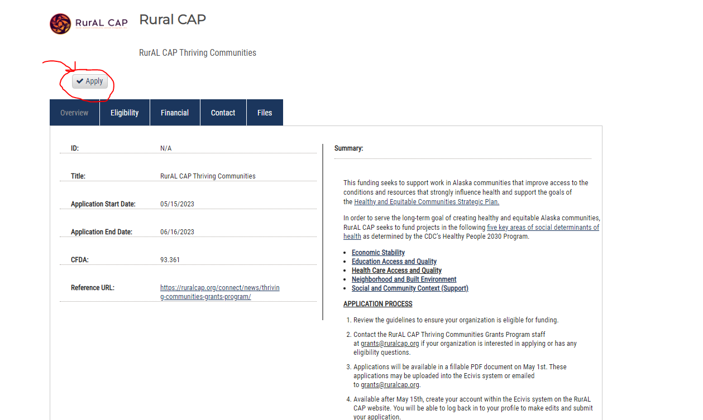

- Click on the green “Create an account” button.

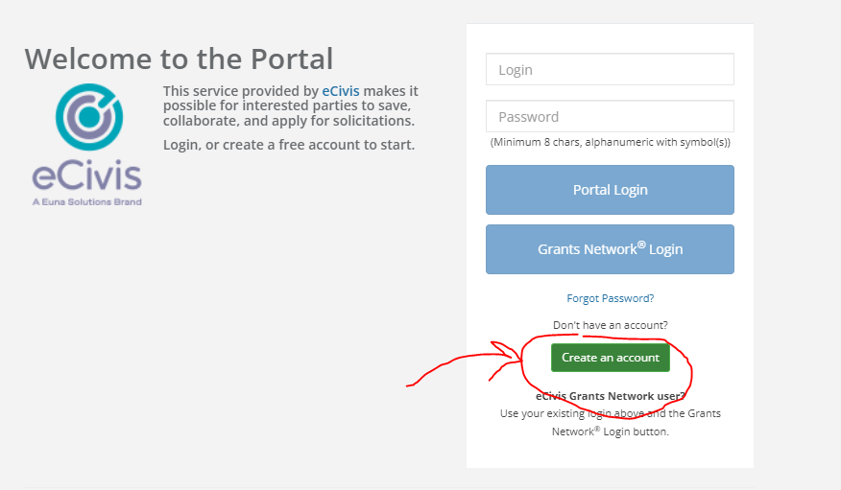

- Enter in your information to create a new account and click on the blue “Sign Up” button.
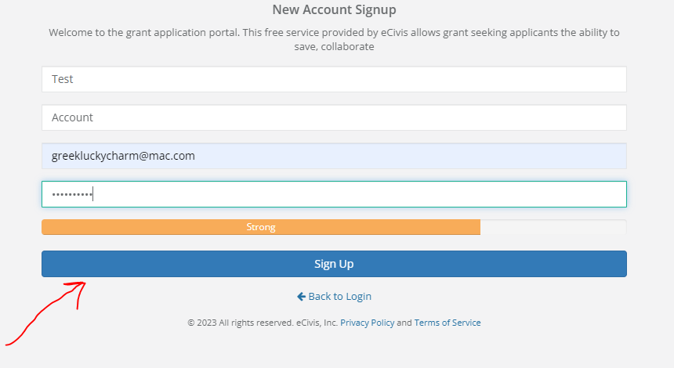

- You will receive this notification. Click on “Back to Login” to log in to the portal and complete the application.
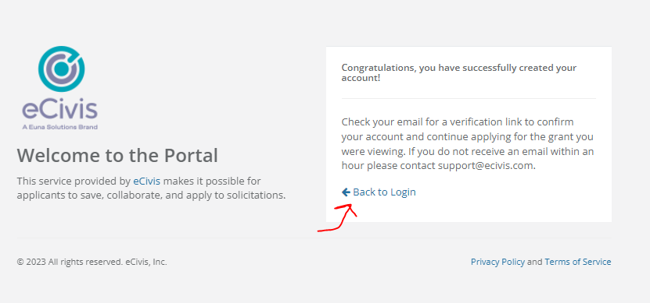

- Enter in the username and password you just created and click on the blue “Portal Login” button.
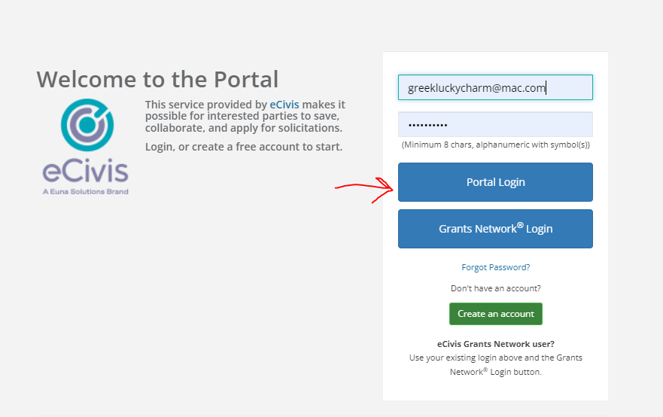

- If you did not verify your email, you will receive this warning notification.
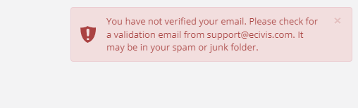

- Check your email for the example email below. Click on the blue “Confirm my account”. Once that is done, you will be able to log into the Ecivis portal.
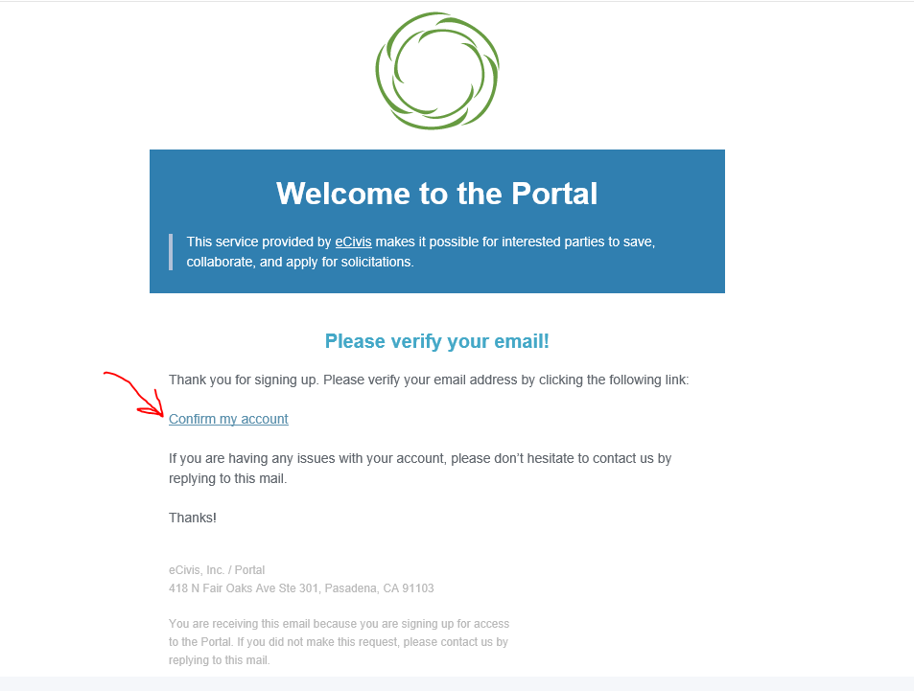

- Click on the blue “RurAL CAP Thriving Communities” button to apply. Then click on the green “Create New Application” button. You will be asked for Profile information about your agency before you reach the application.
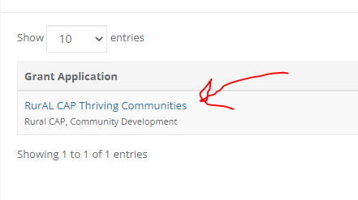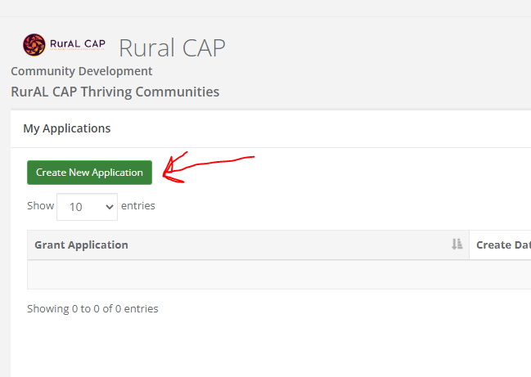

- Click on the blue “Log in with your credentials again to access your application’s account” button.

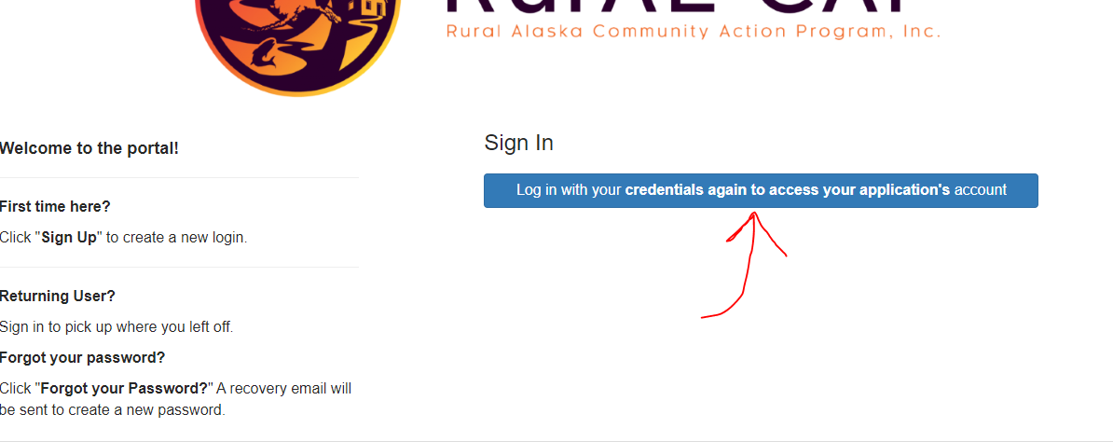
- Click on the blue “Portal Login” button.
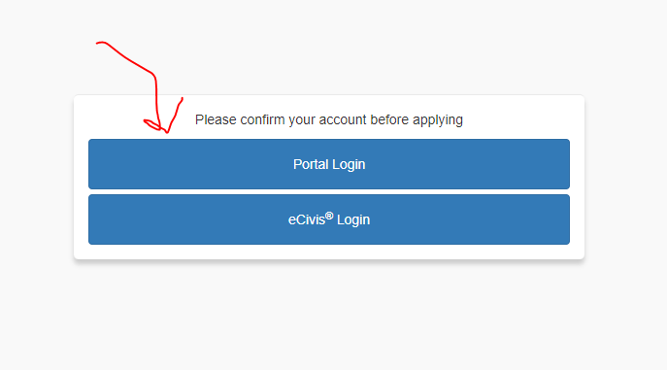
- Enter in your log in information again and click on the blue “Log in” button.
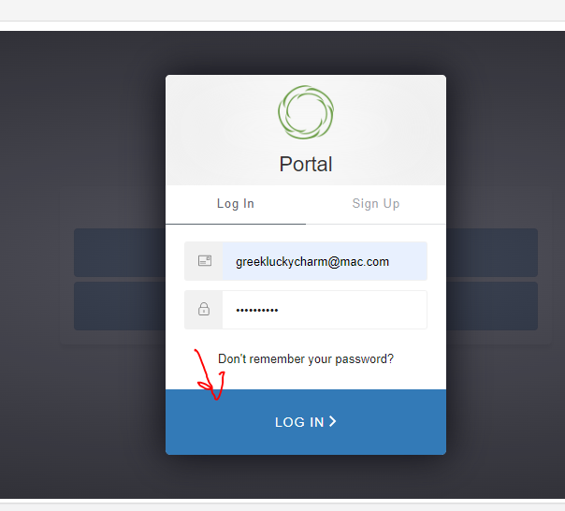

- Click on the blue “Open” button. This will allow you to create your organization profile in our system.

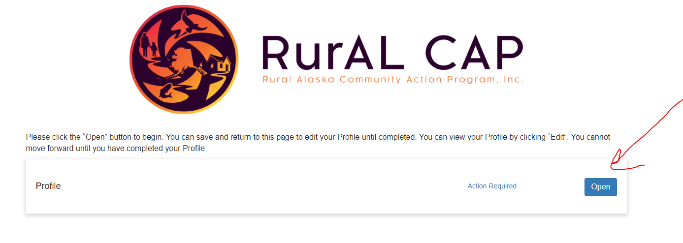
- Click on the blue “Create Profile” button.
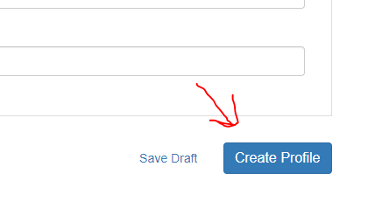
- Click on the blue “Application Submission” to being the application.
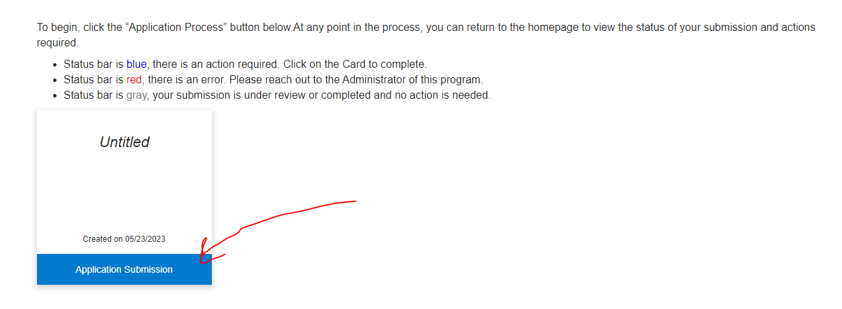
- Click on the blue “Open” button to begin your application.
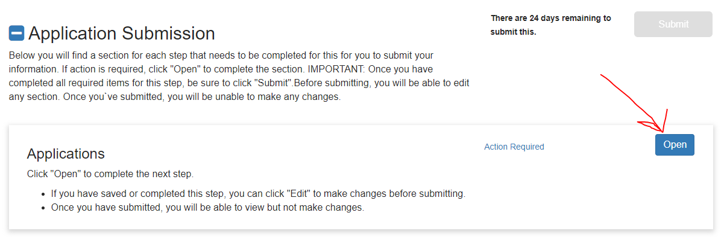

- Fill out the application and upload the applicable documents. You can save the draft and return to submit or click the blue “Mark Complete” button to submit the application. You have the option to Save Draft, Mark Complete or Close on the of the page or the bottom.
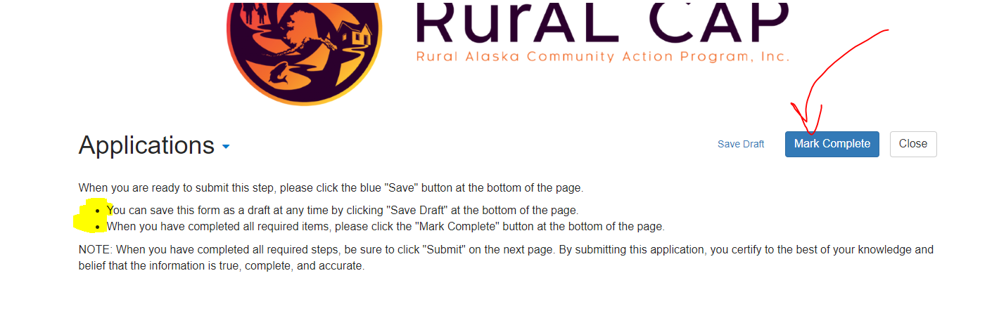

- The bottom of the application asks if you did complete your application goals. You select yes for this question.
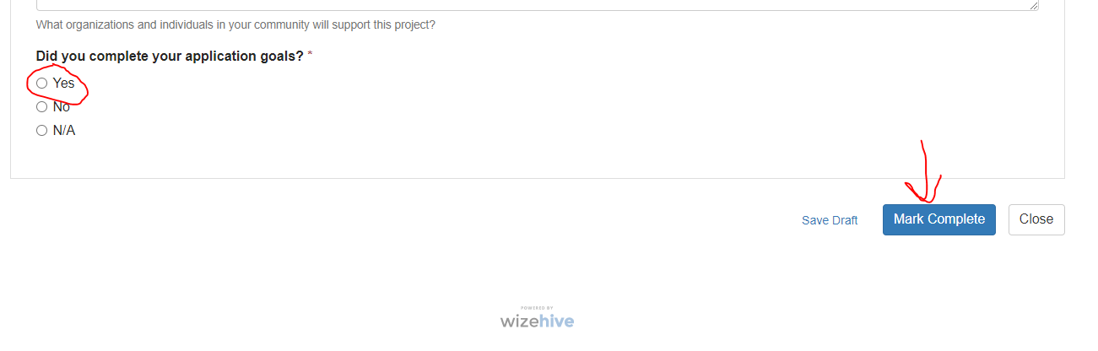

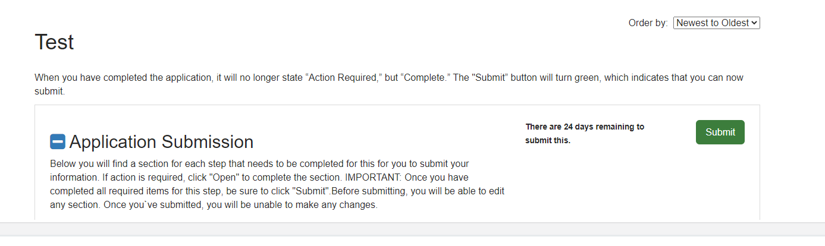
Once application is complete the submit button will be green and you can click submit. You are not done until you have submitted it.

- Once the application is complete and submitted, the email listed on the application will receive a submission notification automatically. If you do not receive one, please let us know at grants@ruralcap.org.

